ASSIGNMENT - 4

1.
create or alter proc spCalcAvgFreightByCustomer
@CustomerId varchar(5),
@AvgFreightOrders money output
as
begin
select @AvgFreightOrders=AVG(Orders.Freight)
from Orders
where Orders.CustomerID = @CustomerId;
return @AvgFreightOrders;
end
go

create or alter trigger tr_insteadOfInsert_orders
on Orders
instead of insert
as
begin
declare @AvgFreight money, @CustomerId nvarchar(5), @insertedFreight money

select * from inserted;

select @CustomerId = CustomerId
from Customers
where CustomerID in (select CustomerID from inserted);

if(@CustomerId is null)
begin
Raiserror('Invalid customer id',16,1)
return
end

select @insertedFreight = Freight
from inserted;

exec dbo.spCalcAvgFreightByCustomer 'RATTC',@AvgFreightOrders=@AvgFreight output;

if(@AvgFreight < @insertedFreight)
begin
Raiserror('Freight amount excluded',16,1)
return
end

Print 'tr_insteadOfInsert_orders'
insert into Orders( CustomerID, EmployeeID, OrderDate, RequiredDate, ShipVia, Freight, ShipName, ShipAddress, ShipCity,ShipPostalCode, ShipCountry)
select CustomerID, EmployeeID, OrderDate, RequiredDate, ShipVia, Freight, ShipName, ShipAddress, ShipCity,ShipPostalCode, ShipCountry
from inserted;

end
go

create or alter trigger tr_insteadOfUpdate_orders
on Orders
instead of update
as
begin
declare @AvgFreight money, @CustomerId nvarchar(5), @insertedFreight money,@deletdFreight money, @OrderId int

select * from inserted;
select * from deleted;

select @CustomerId = CustomerId
from Customers
where CustomerID in (select CustomerID from inserted);

select @OrderId = OrderId
from Orders
where OrderID in (select OrderID from inserted);

if(@CustomerId is null or @OrderId is null )
begin
Raiserror('Invalid customer or order id',16,1)
return
end

select @insertedFreight = Freight
from inserted;
select @deletdFreight = Freight
from deleted;

exec dbo.spCalcAvgFreightByCustomer 'RATTC',@AvgFreightOrders=@AvgFreight output;

Print 'Deleted Freight ' + CAST(@deletdFreight as varchar) + ' \n Inserted Freight : ' + CAST(@insertedFreight as varchar) + ' \n Updated : ' + CAST(@AvgFreight as varchar);

if((@insertedFreight <> @deletdFreight) and (@AvgFreight < @insertedFreight))
begin
Raiserror('Freight amount excluded',16,1)
return
end

Print 'tr_insteadOfUpdate_orders'

update Orders
set Freight = @insertedFreight
where OrderID = @OrderId;

end
go

insert into Orders ( CustomerID, EmployeeID, OrderDate, RequiredDate, ShipVia, Freight, ShipName, ShipAddress, ShipCity,ShipPostalCode, ShipCountry)
values('RATTC',2,'1998-05-12 00:00:00.000','1998-05-24 00:00:00.000',2,168,'Rattlesnake Canyon Grocery','2817 Milton Dr.','Albuquerque',87110, 'USA')

update Orders
set Freight = 114.50
where OrderID = 11078;
go

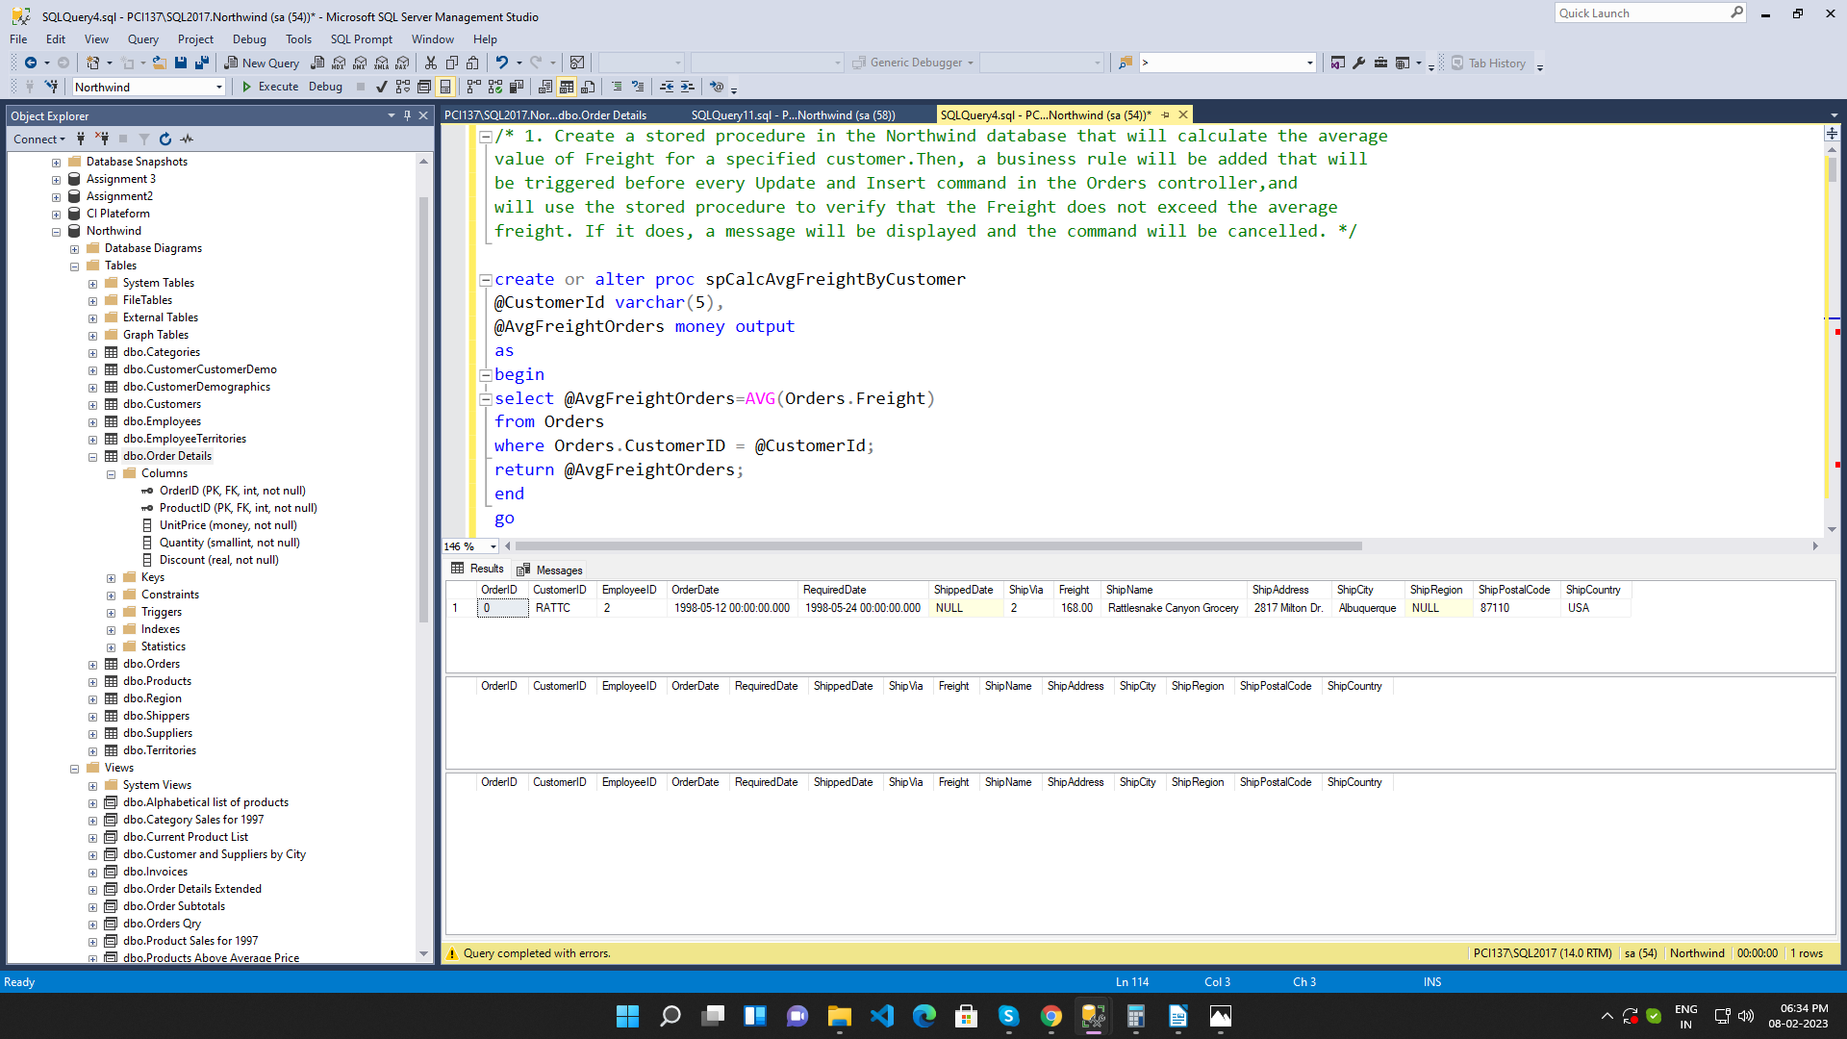

2.
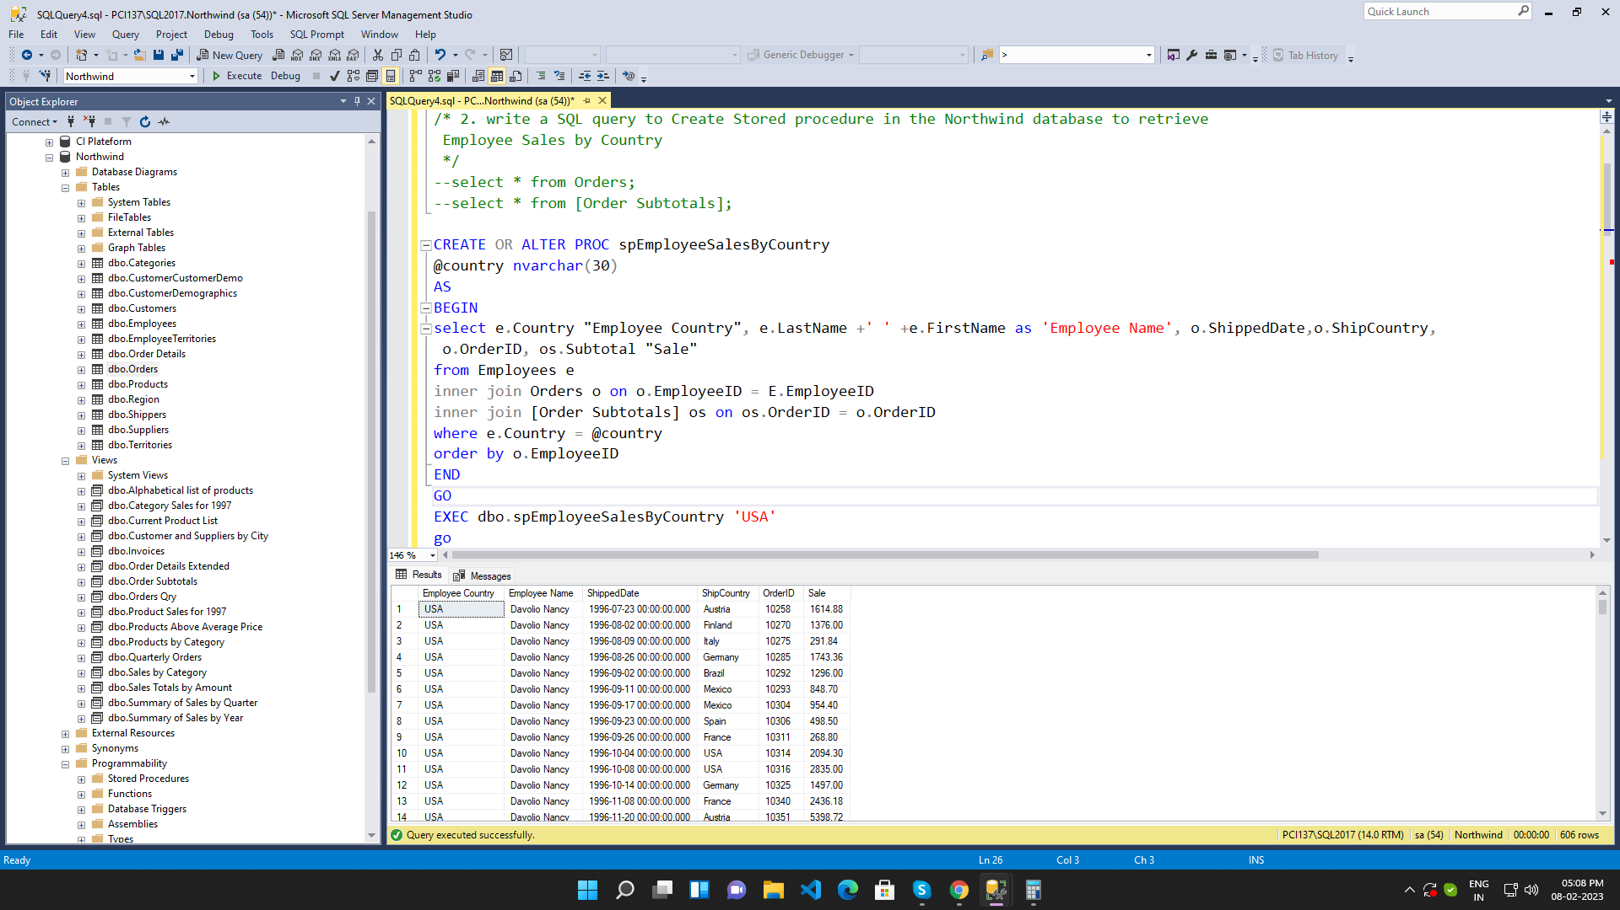

3.
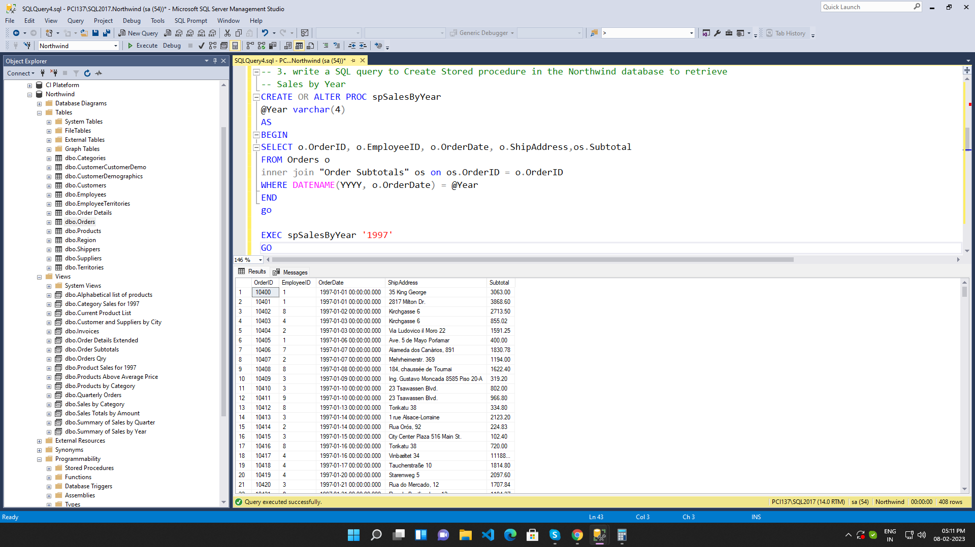

4.
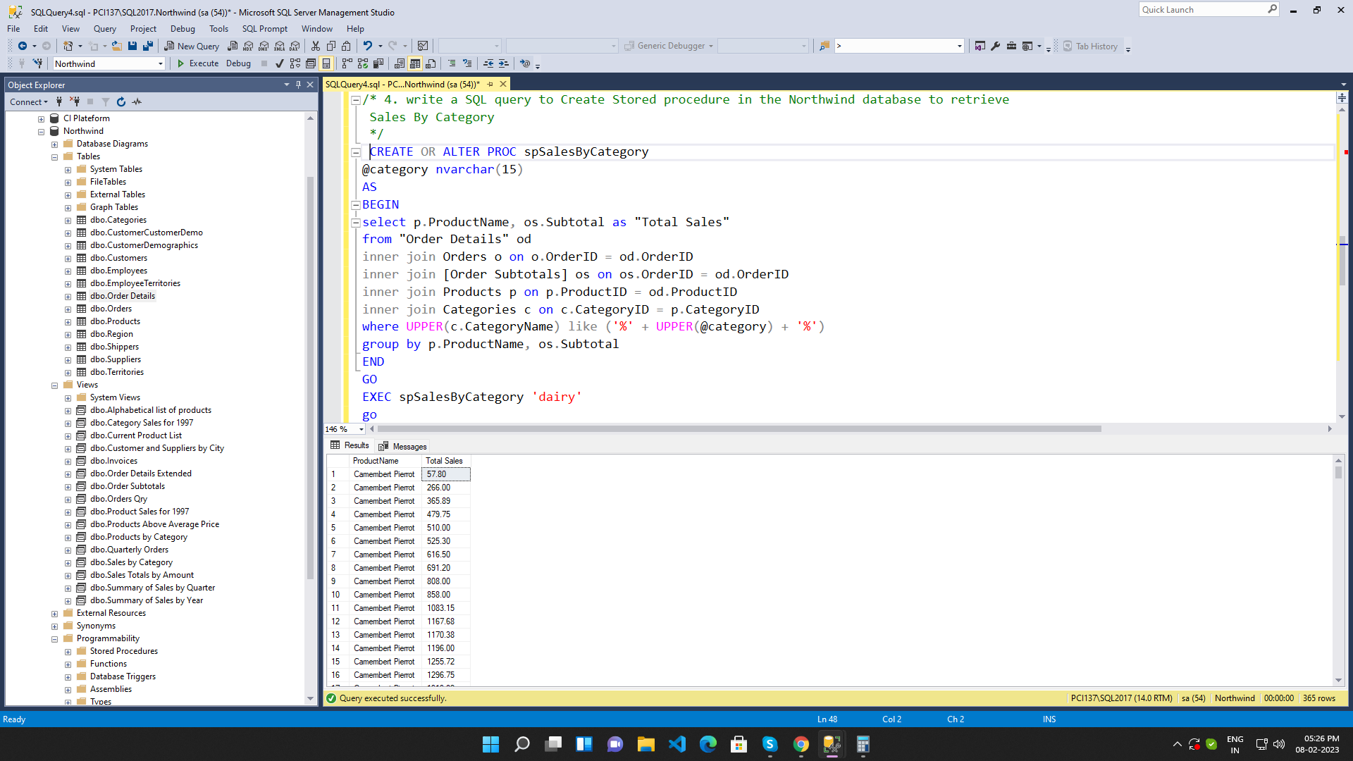

5.
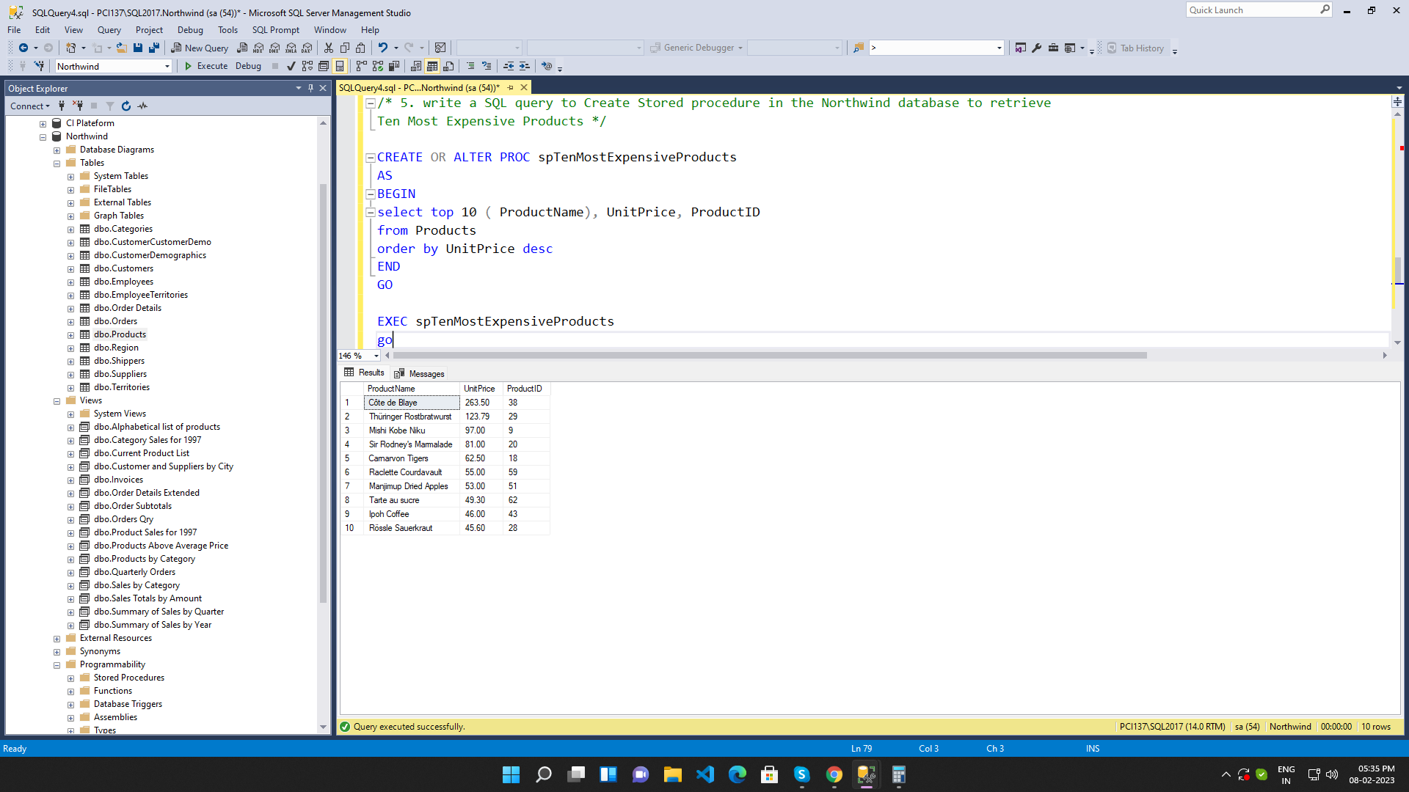

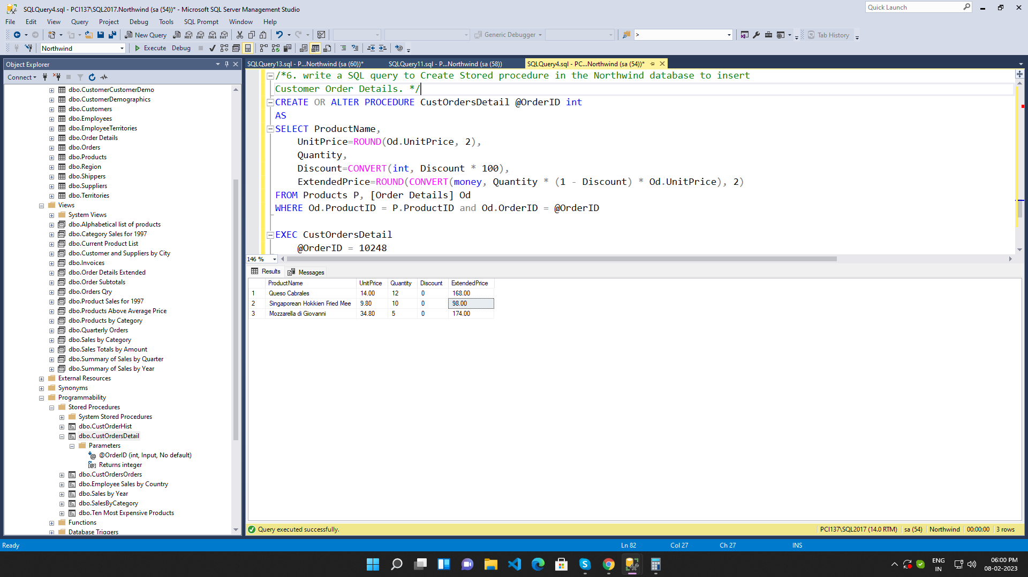
6.

7.
